Exploring Greater China Regionalism
Unit Plan

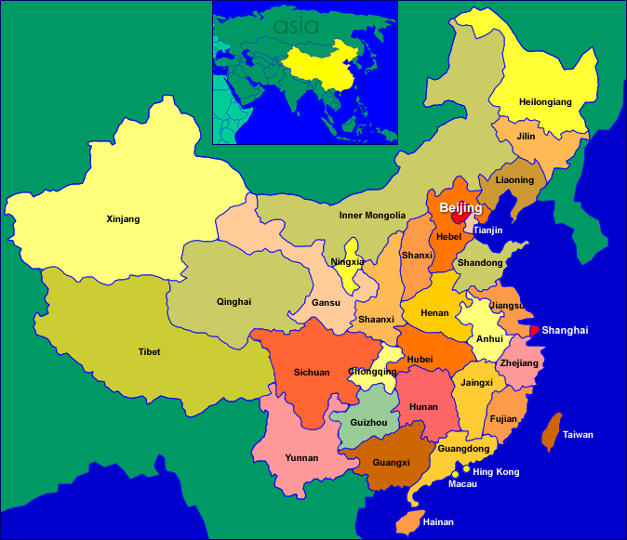

Background and Relevancy
In the past, the initial phases of my class’ study of China, students complete a Relief Map and Freehand Map of China’s physical and cultural features. Through these lessons students are able to get a general understanding of the physical and cultural landscape of greater China. They are also able to use this information to understand settlement patterns and begin to explore Chinese history and culture.
These lessons provide an overview of greater China, but they do not provide students with specific or intimate knowledge of the diverse range of cultural and physical regions of China. The following lessons will give students the opportunity to gain a deeper, more critical, and personalized understanding of China’s diversity. It will also tie directly into common core standards for my social studies unit on China and for my language arts unit on informational writing.
Overview

Students will learn about the diversity of Chinese society through site-specific study of its municipalities, provinces, and regions.

Students will research and report on specific aspects of Chinese society (e.g. history, food, religion, geography, resources, economy, etc.) for a municipality, province, or autonomous region in an information book. Students will compile this information book using Microsoft PowerPoint for an assigned municipality, province, or region. Students will have the opportunity to experience the cultural and geographic diversity of greater China by viewing, commenting on, and analyzing their peer’s PowerPoint presentations in a cultural exploration tour day of their own. Students will also be given an opportunity to critically think and reflect on their geographic area of study as well as their peer’s.

Guiding Questions

1. How do we understand diversity in Chinese society?
2. What similarities and differences exist among China’s cultural and physical regions?
3. What aspects of Chinese society are geographically unique?

Objectives

Students will be able to:

1. Identify major Chinese municipalities and provinces
2. Use the Internet, databases, and library to research and gather information and media on aspects of Chinese society
3. Use Microsoft PowerPoint to compile a presentation on one municipality or province
4. Analyze and understand aspects of Chinese society for selected municipality, province, or region to include, but not limited to:
a. Map Location
b. Physical Features (e.g. rivers, mountains)
c. Climate
d. Basic Demographics (population, area, ethnicity)
e. History
f. Language and Dialect
g. Economy and Resources
h. Cultural Features
i. Current Event
4. Summarize information regarding their municipality, province, or region.
5. Compare and contrast similarities and differences among Chinese municipalities, provinces, and regions.
6. Reflection on project and learning.

Standards Addressed

W.6.2 Write informative/explanatory texts to examine a topic and convey ideas, concepts, and information through the selection, organization, and analysis of relevant content.
WHST.6-8.6 Use technology, including the Internet to produce and publish writing and present the relationships between information and ideas clearly and effectively
WHST.6-8.8 Gather relevant information from multiple print and digital sources, using search terms effectively; assess the credibility and accuracy of each source; and quote or paraphrase the data and conclusions of others while avoiding plagiarism and following a standards format for citation.
WHST.6-8.9 Draw evidence from informational text to support analysis, reflection, and research
SL6.2 Interpret information presented in diverse media and formats and explains how it contributes to a topic, text, or issue under study

Activities and Materials

Day 1- Introduction to “Greater China Regionalism” using video (https://www.youtube.com/watch?v=NS5uPtfm0_s), PowerPoint, and discussion. Go over overview. Students assigned municipality, province, or region and begin exploring in books, computers, and for homework.
01 – PowerPoint
02 – Overview
03 – Sign Up List

Day 2 – Go over list of primary sources. Students use the checklist and list of primary sources to start their research.
04 – List of Primary Sources

Day 3 – Go over checklist and paper slides. Continue research using student research and selected sites.
05 – Checklist
06 – Paper Slides

Day 4 – Overview of Rubric. Continue research using student and selected sites.
07 – Rubric

Day 5 – Mini-lesson on peer revision of template. Peer revision of templates.
08 – Peer Revision

Day 6 – Overview of PowerPoint. Students begin PowerPoint work.

Day 7 – Overview of Introduction and Reflection Slides. PowerPoint compilation.
(show 01 - PowerPoint Intro and Reflection slides)

Day 8 – Overview of Topic Slides. Powerpoint compilation.
(show 01 - PowerPoint Topic Slides)

Day 9 – Submission of Rough Draft. Peer Revision of PowerPoint presentations.
(see 08 - Peer Revision)

Day 10 – Publication and Exposition through cultural exploration day.

Day 11 – Reflection and Extension Activities.
09 – Reflection Prompts

Assessment

1. Informal assessments of skills and concepts.
2. Rubric of PowerPoint Presentation.
2. Analysis and Reflection assessment.

Extension

1. Students will be able to explore additional aspects of their municipality, province or region, and develop slides based on their findings to share with class.

Sources

1. CE of Greater China Trip and Coordinator discussions
2. See “04 - List of Primary Sources”

